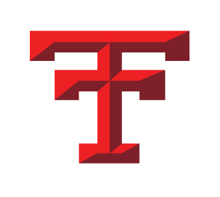
Gregg Grinsteinner
Athletic Director
810 Empire Road – P.O. Box 1177
Dickinson, ND 58602
P: (701) 483-6081 F: (701) 483-1450
Gregg.Grinsteinner@k12.nd.us

July 19, 2017

Dear Titan Parents,

Back to school commercials are already starting. That means the fall sports season is not too far away. With that being said, I would like to give you some important reminders before our seasons start in August.

- Our fall sports parent meeting will be Monday, August 7 in the auditorium at 6:30 PM. We ask that you and your student-athlete(s) be there to listen to important information from Fr. Hochhalter, each sport’s coaches, and from myself.

- Your student-athlete must have a new physical BEFORE they will be able to practice. Free physicals will not be happening this year. CHI is offering a well-child physical (see Trinity website for more info.)

- Also on the Trinity website are all the forms your student-athlete needs to have filled out and signed before they may practice. These forms are the following:
- Physical Form
- Concussion and Impact Testing – Impact testing will happen on August 8 (2:15 – 4:30) and August 10 (3:15 – 5:00). CHI St. Alexius’ Sports Medicine will be in charge of this. You need to be tested every 2 years.
- Insurance form for each family
- Trinity and NDHSAA Student-Athlete Code of Conduct and Rules form.

These forms may be turned into the office at any time. Athletes will NOT be able to practice or participate until all of these forms are signed and turned in.

- Starting dates for fall sports are as follows:

Football – Wednesday, August 9
Volleyball – Monday, August 14
Cross Country – Monday, August 14 (Co-op with Dickinson High)
Girls Golf – Monday, August 7 (Co-op with Dickinson High)
Girls Swimming & Diving – Monday, August 14 (Co-op with Dickinson High)

Please feel free to contact Trinity or myself if you have any questions. Enjoy the rest of the summer!

Gregg Grinsteinner, AD
Trinity High School

